Hyoungjun Lee  
2/19/20  
Project 2A  
Computer org&programming

Task 3

Parallel programming skills

Foundation-

**Identifying the components on the raspberry PI B+**

HDMI port, USB port, Power port, SD card slot, Camera, display connecting slot, ethernet Controller, ethernet port, CPU/RAM

**How many cores does the Raspberry Pi’s B+ CPU have**

it has quad-core, so 4 CPU

**List three main differences between X86 (CISC) and ARM Raspberry PI (RISC).Justify you answer and use your own words (do not copy and past)**

1. CISC has less register than RISC, also uses little endian when you store
2. CISC used for PC, or large capacity , because containing more feature instruction set, allow complex instructions to access into memory
3. RISC has simple instruction set, because main purpose is for small devices such as phone, tablets etc.

**What is the difference between sequential and parallel computation and identify the practical significance of each?**

Difference between sequential and parallel computation is sequential can handle only one instruction when parallel computation can handle multiple, by using parallel computation we can multi-tasking, practical significance of sequential is easy writing, and parallel is multi tasking

**Identify the basic form of data and task parallelism in computational problems**

Data parallelism – same computation or one operation into multiple data items

Task parallelism – allow one task to one core, another to one core, multiple function or thread than data parallelism

**Explain the differences between processes and threads**

when running the program, process does not share memory, thread is subset of process, threads share their common memory with the process, and same address

**What is OpenMPand what is OpenMP pragmas?**

OpenMP – compiler which can do multithreading, makes user’s task simpler, also reducing an errors

OpenMP pragmas – compiler that directive to programs into parallel computation, generate thread code

**What applications benefit from multi-core(list four)?**

Benefits of using multi-core application are data server, CAD/CAM , multimedia application ,data server

**Why Multicore? (why not single core, list four)**

Multicore can running multiple process, allow to operate multi tasking, execute faster than single core, in single core it could be heat up by speeding up , muticore manage this problem, process in short time , output faster

B) Parallel Programming Basics

as following guide from top to bottom, I wrote first code and ran it, it did not run what I expected because id declared in main method, but there’s more than 1 id in code

As I write code into PI and check the result, I can double check all the cores share same memory, cannot have multiple variables in same id. Have to declare other

So first part did not run correctly,

As shown in below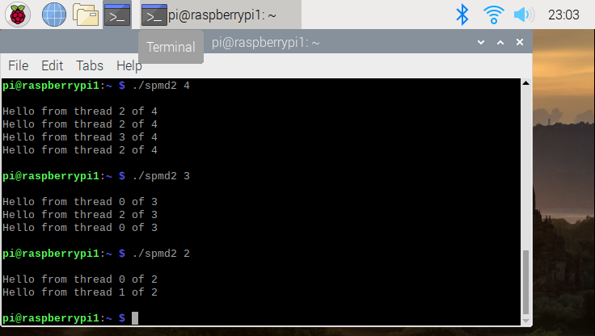

Then change the id value inside, int id , I got correct answer what I expected

Second running result shown in below

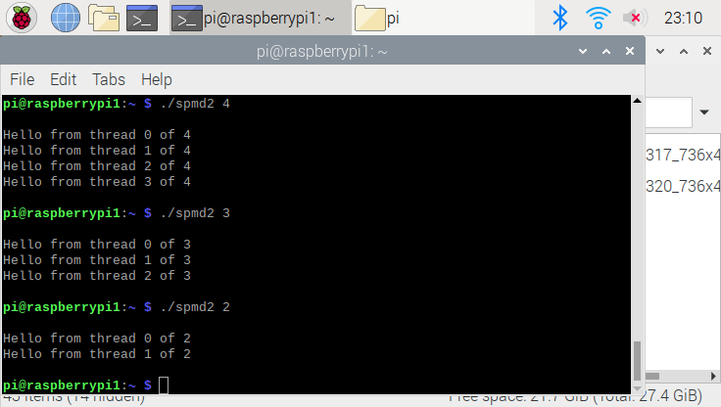

Now, working parallel